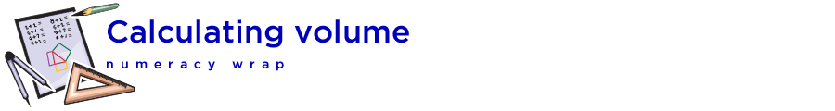

## Teaching notes

This numeracy wrap addresses outcomes from the NSW Syllabus for the Australian Curriculum Mathematics K-6 Syllabus 2018, © Board of Studies, NSW:

Measurement and Geometry: Volume and Capacity

MA3-11MG – Selects and uses the appropriate unit to estimate, measure and calculate volumes and capacities, and converts between units of capacity.

When engaging with this resource, students will:

* find the relationship between, length, width (or depth), height and volume of rectangular prisms
* calculate the volume of rectangular prisms
* investigate the cubic metre.

| Activity | Description |
| --- | --- |
| naplan_one | Students are shown a strategy for calculating the volume of rectangular prisms made with 1 cm cubes. They practise the strategy and check their answers. |
| naplan_two | In pairs, have students use 8 MAB (base ten blocks) or other 1 cm cubes to build different-shaped rectangular prisms. Though the prisms may look different, the space each takes up (its volume) is the same. |
| naplan_three | Students extend and consolidate their learning in activity 3. The ‘Making prisms’ game would be best demonstrated on the interactive whiteboard. Students could play the game in pairs on the printable worksheet provided. |